**Add User by Console Access (ID & Password)**

: Login to your IAM console

: Click on **add users**

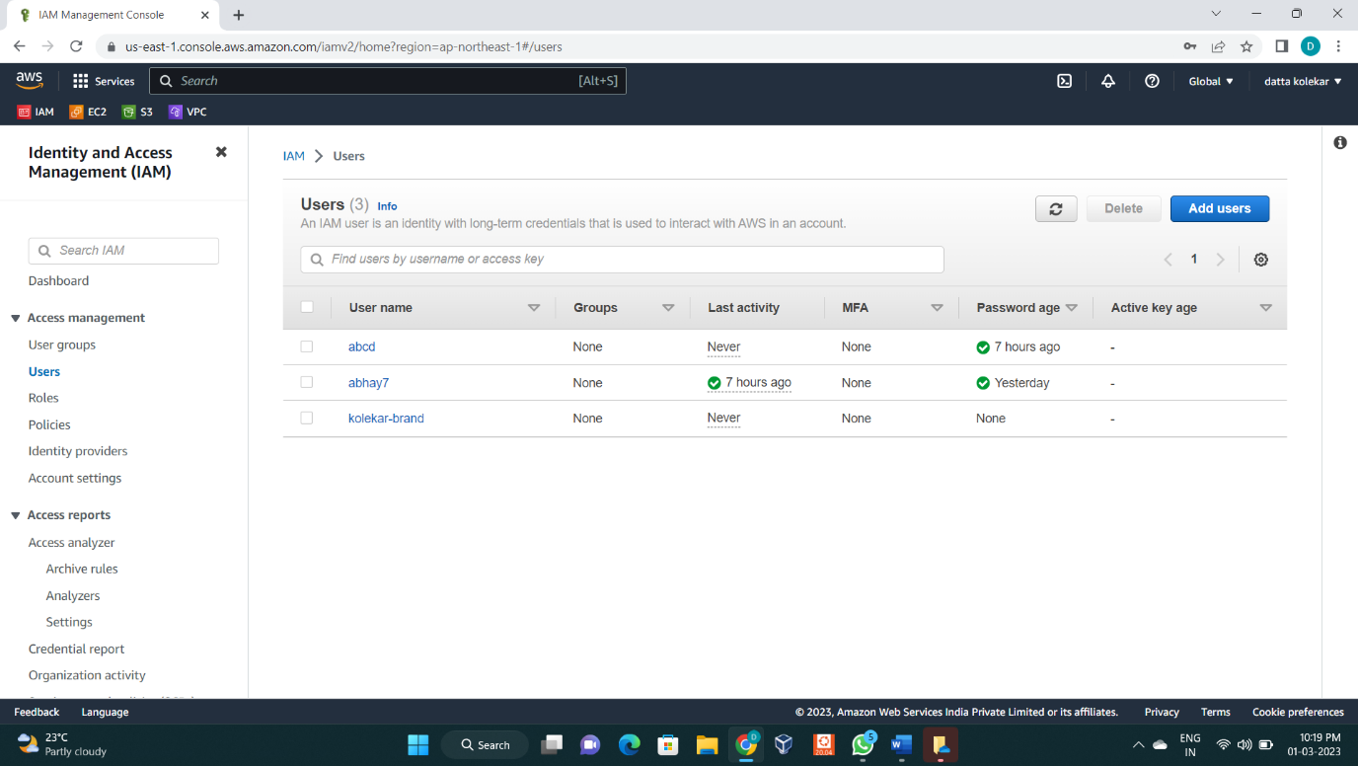

**Step 1 :** Specify user details

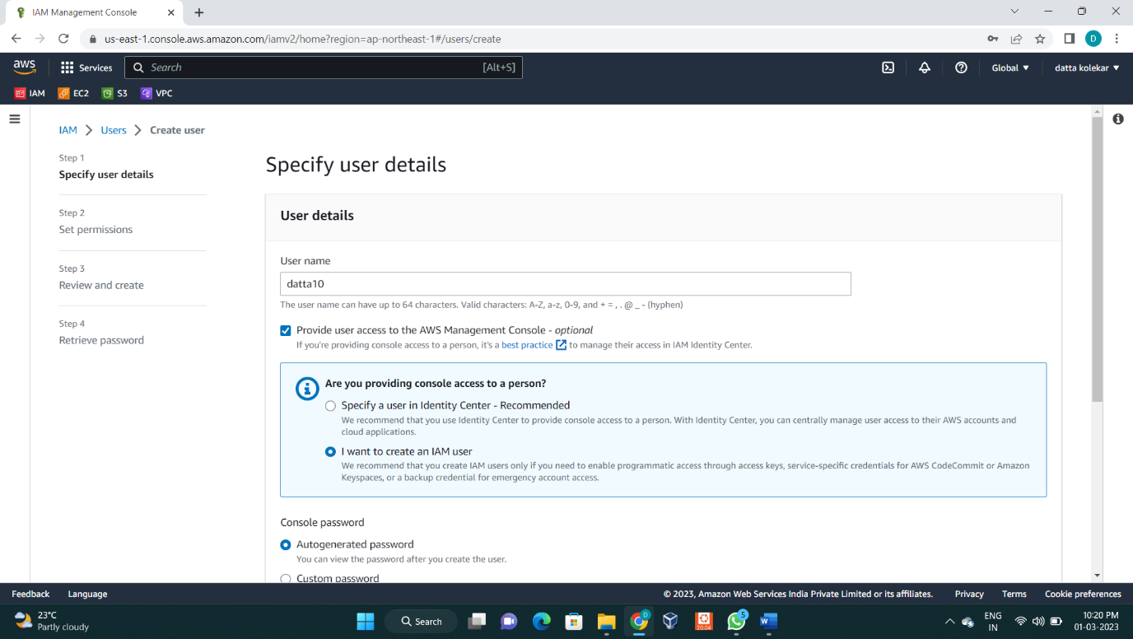

: Enter User name

: select I want create an IAM user

: Select custom password and enter your password

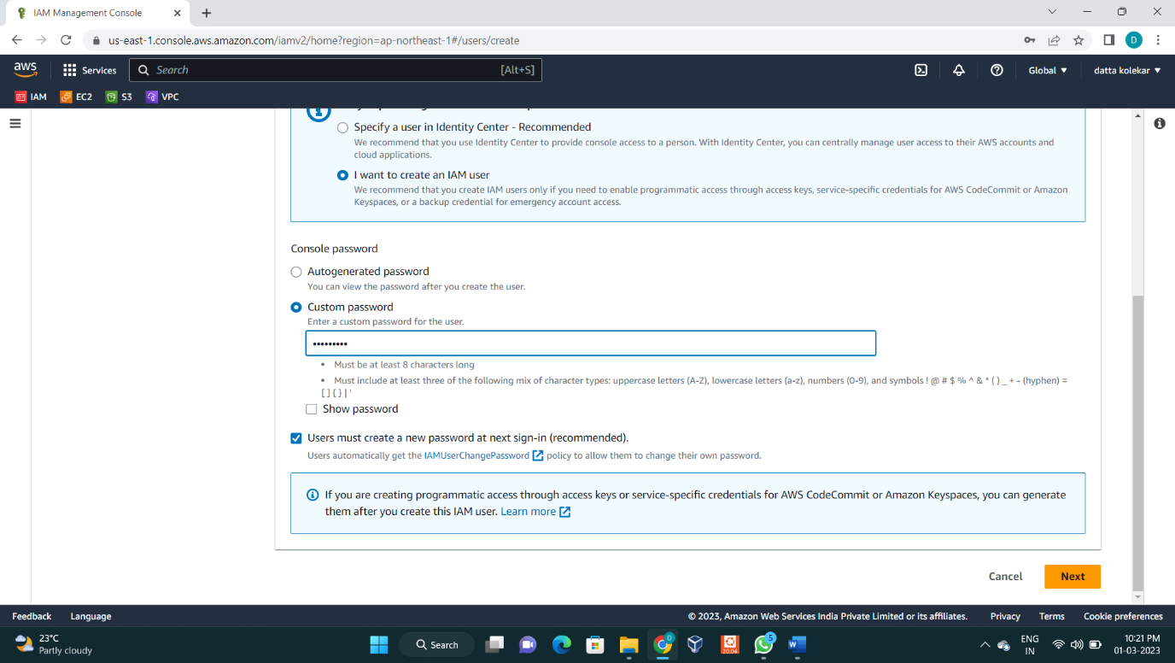

**:** Click on Next

**Step 2 :** Set permissions

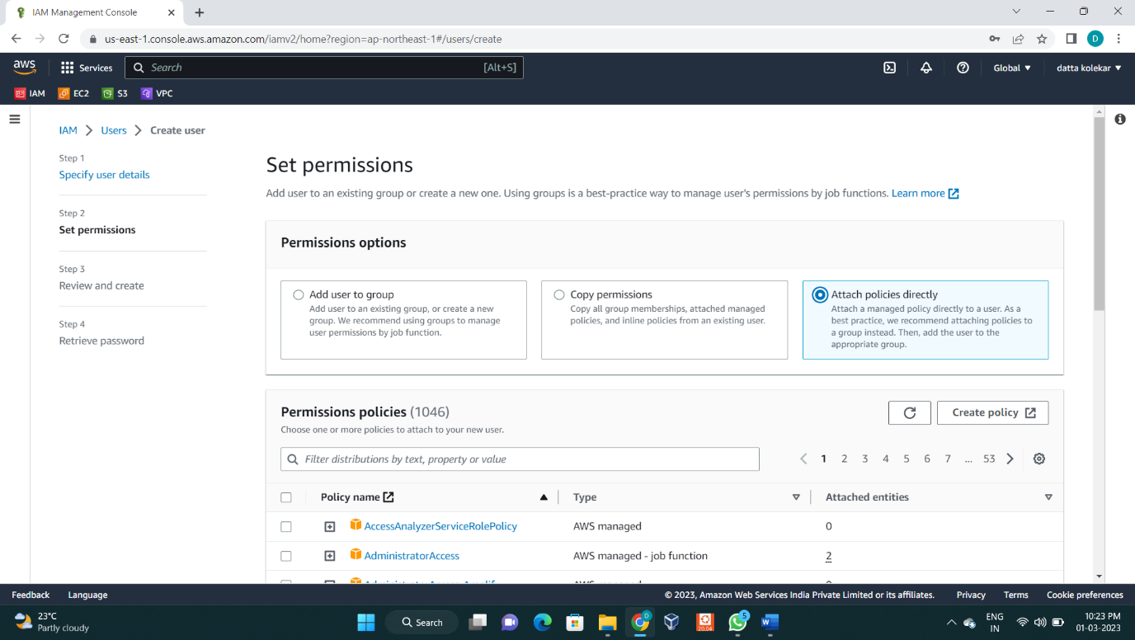

: Select Attach policies directly

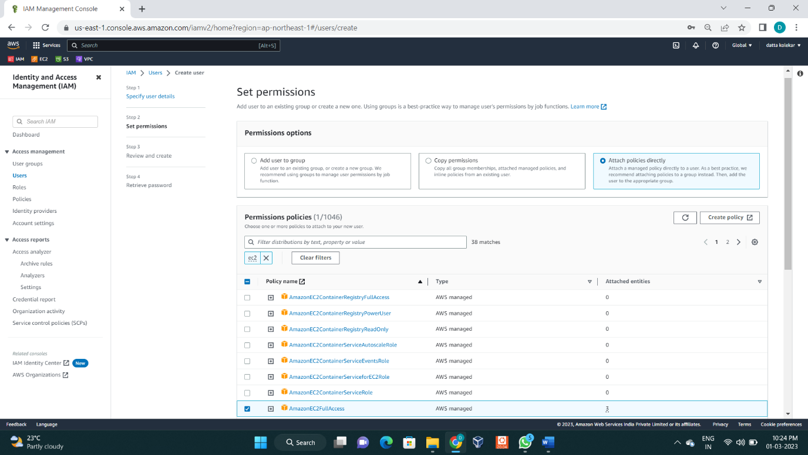

: Select policies **AmazonEC2fullaccess**

**:** Click on Next

**Step 3 :** Review and create

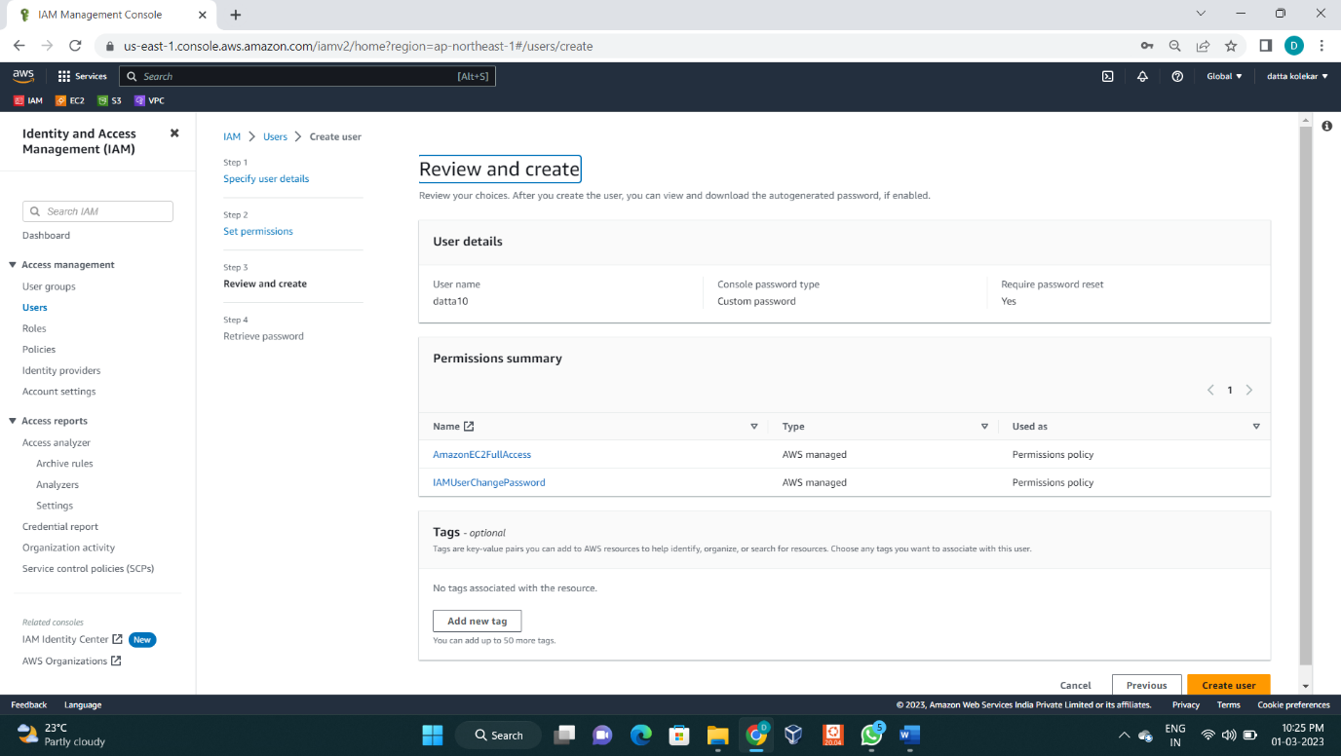

: Click on create user

**Step 4 : Retrive password**

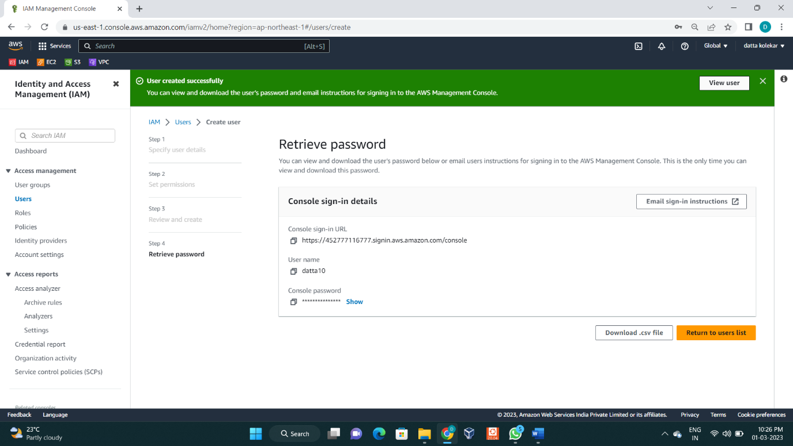

: We can Download .csv file .

: So now user **datta22** has been created by Console Access.